Exercise 1: Implementing the Singleton Pattern
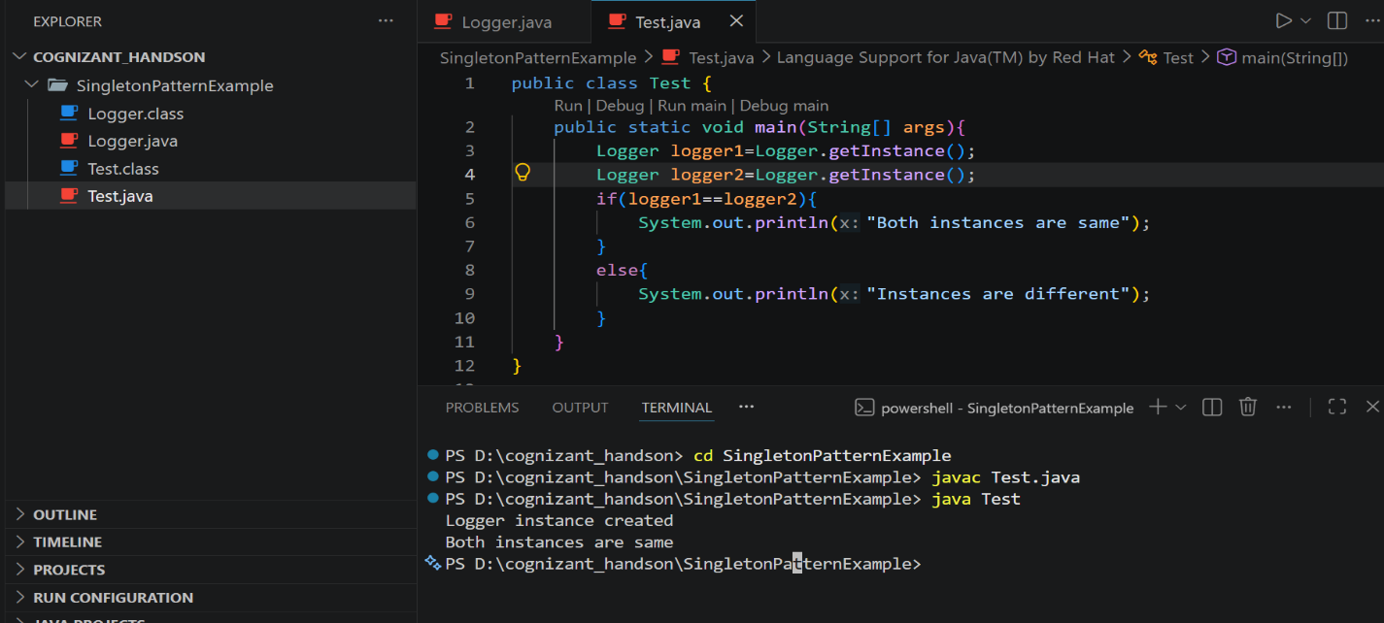
Exercise 2: Implementing the Factory Method Pattern
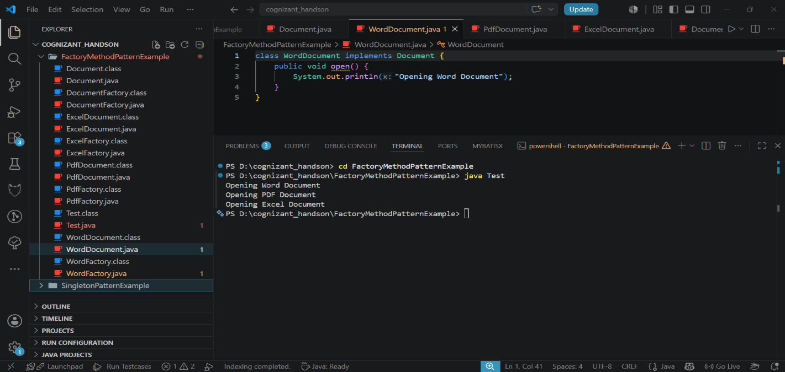
Exercise 3: Implementing the Builder Pattern
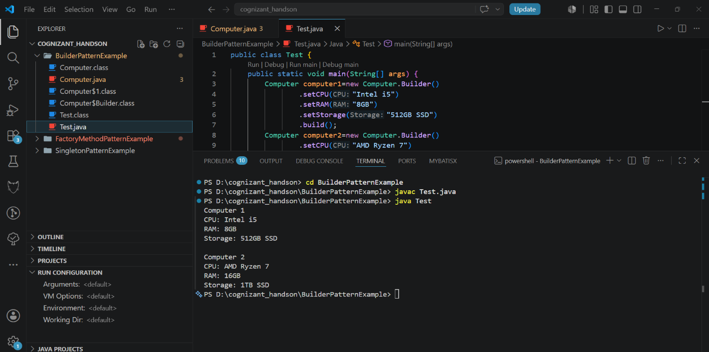

Exercise 4: Implementing the Adapter Pattern
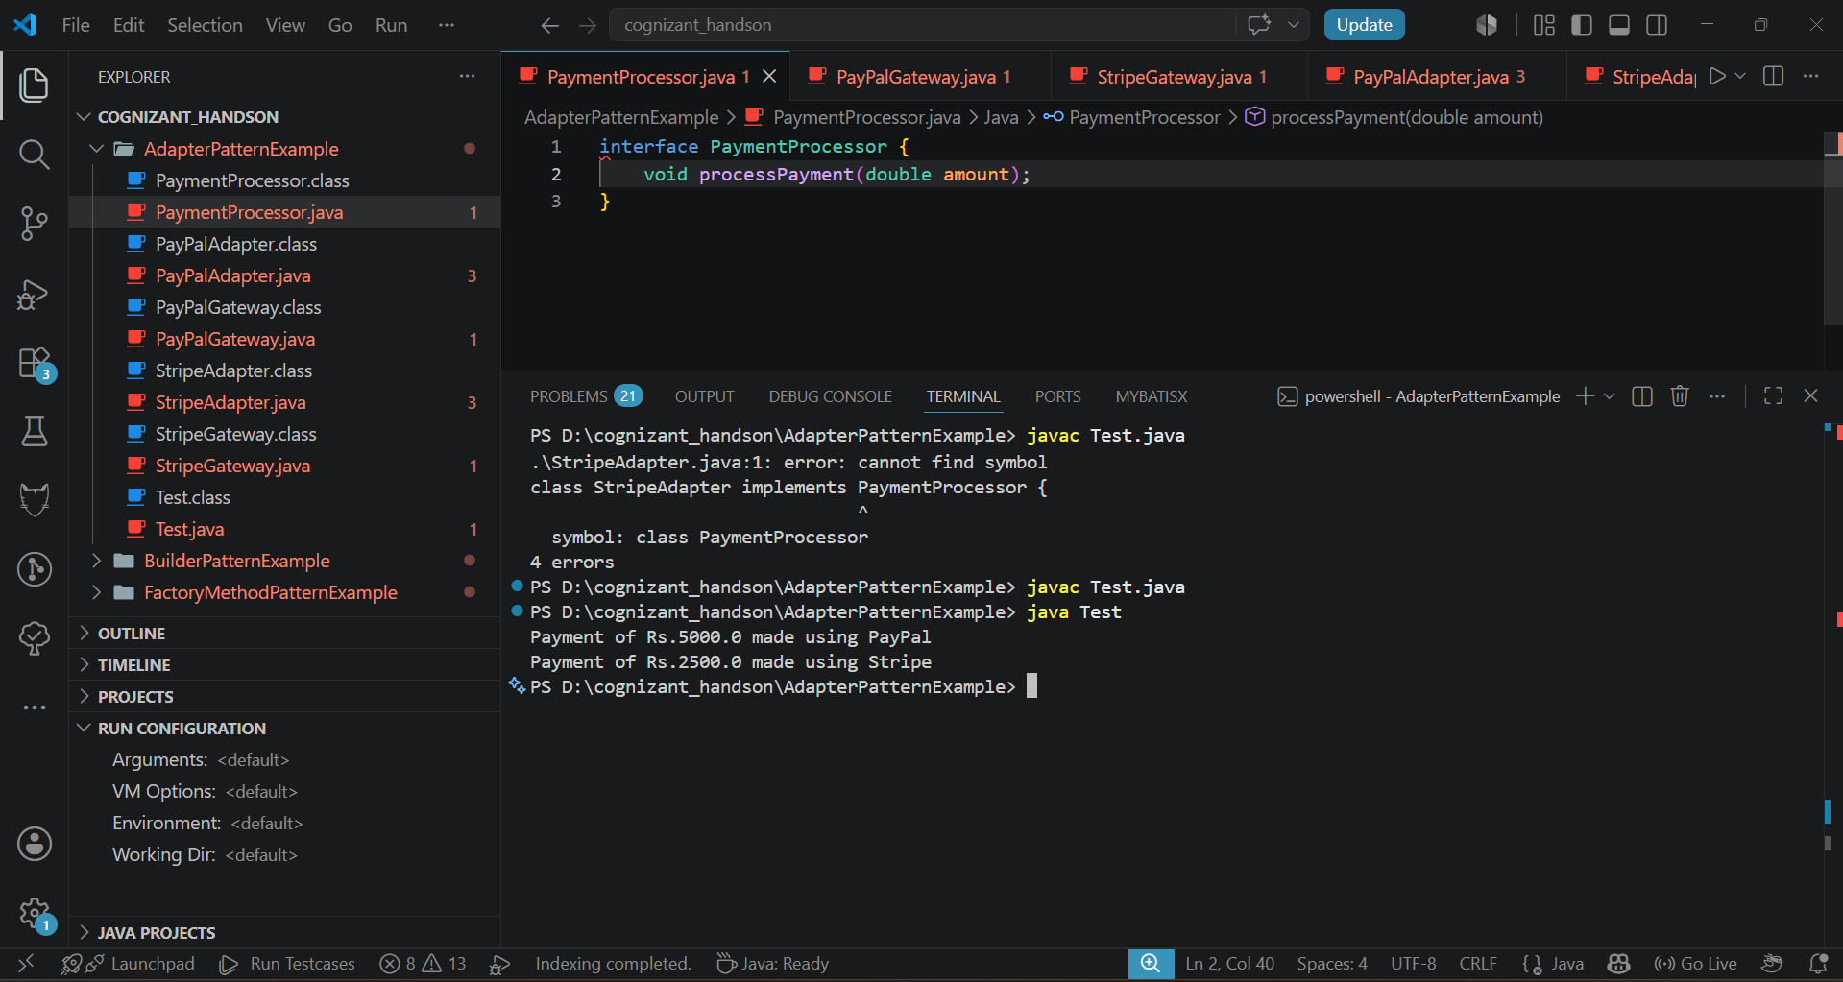
Exercise 5: Implementing the Decorator Pattern
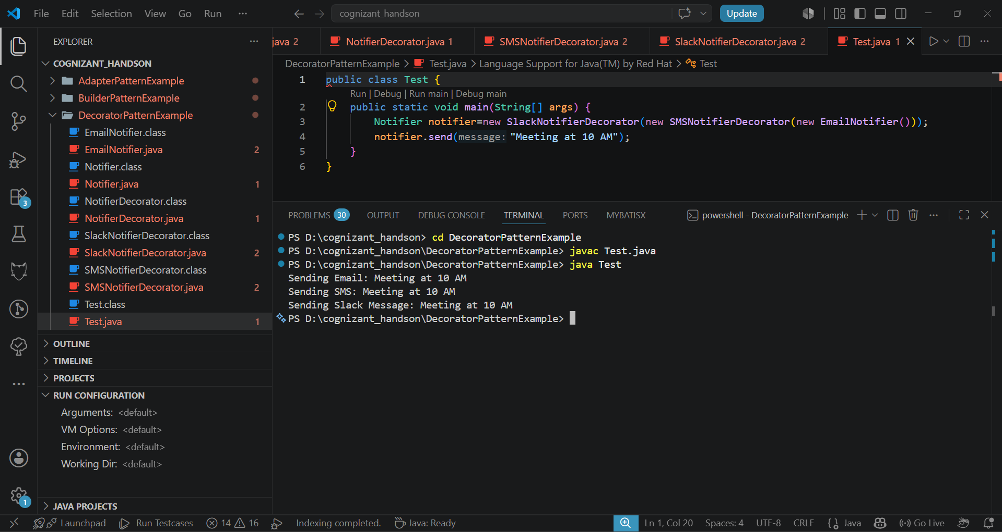
Exercise 6: Implementing the Proxy Pattern
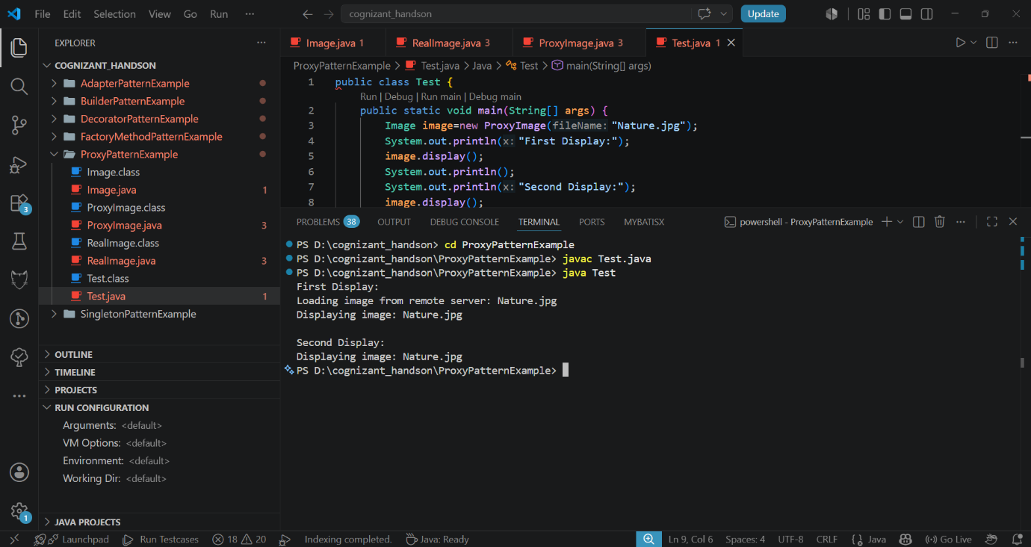

Exercise 7: Implementing the Observer Pattern
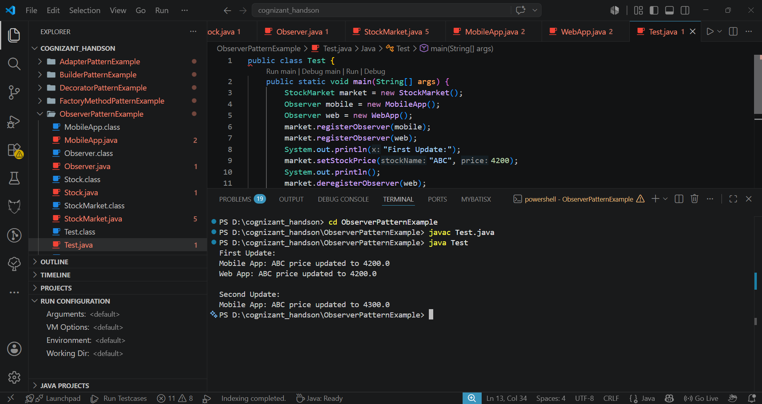
Exercise 8: Implementing the Strategy Pattern
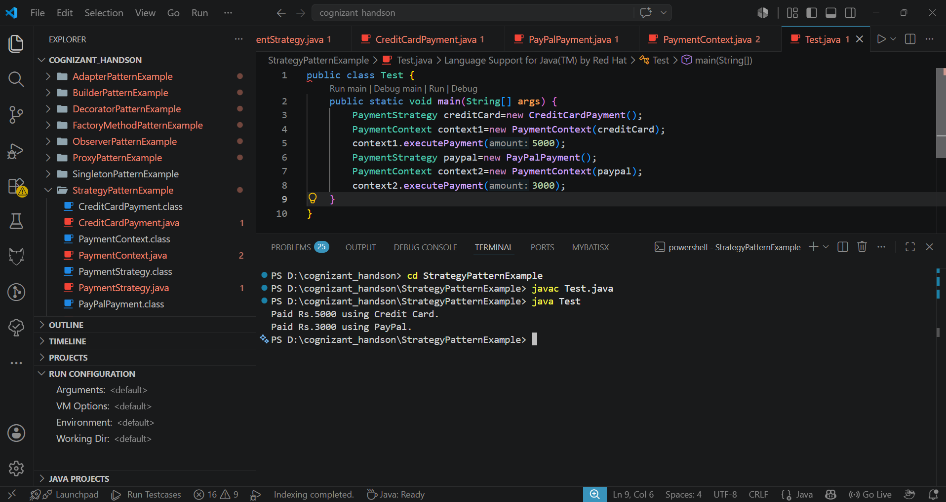
Exercise 9: Implementing the Command Pattern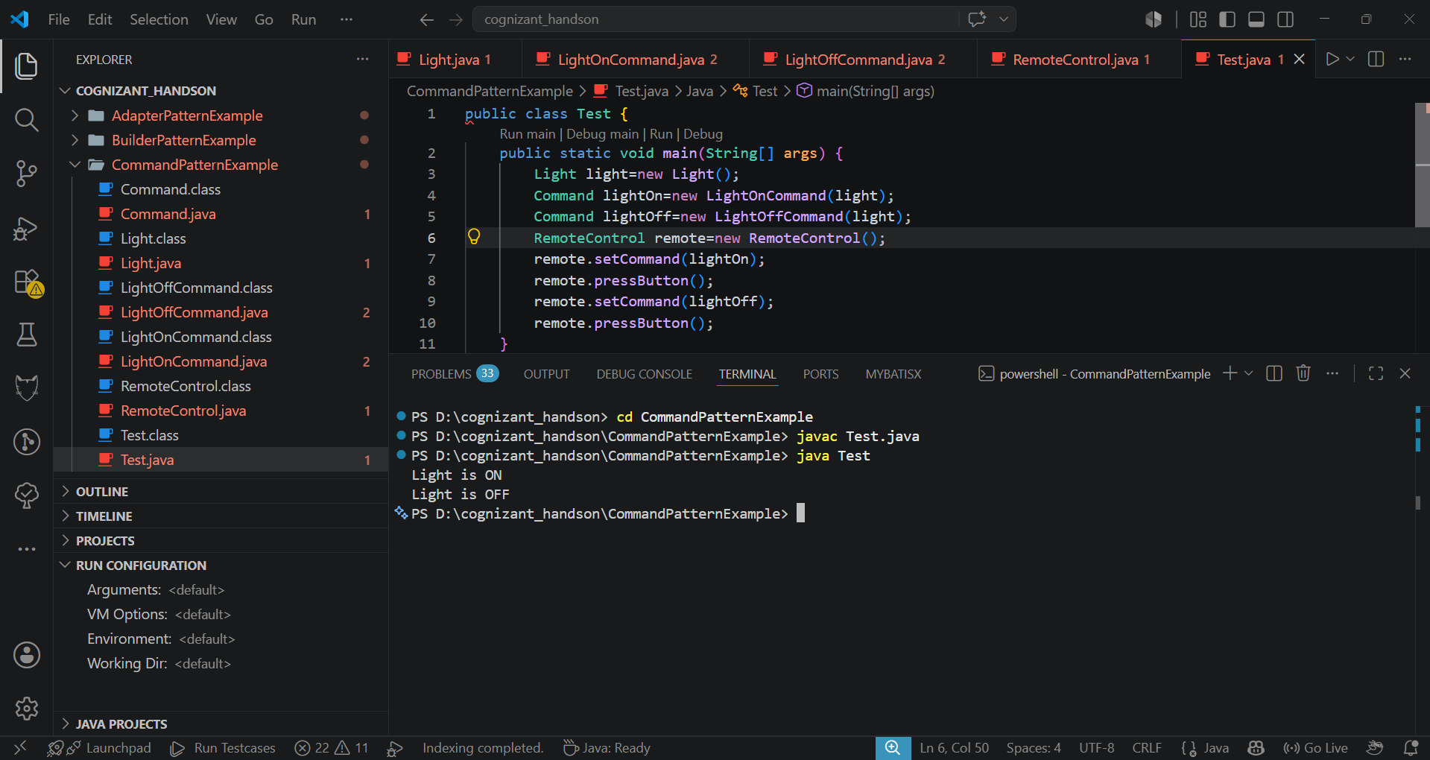
Exercise 10: Implementing the MVC Pattern
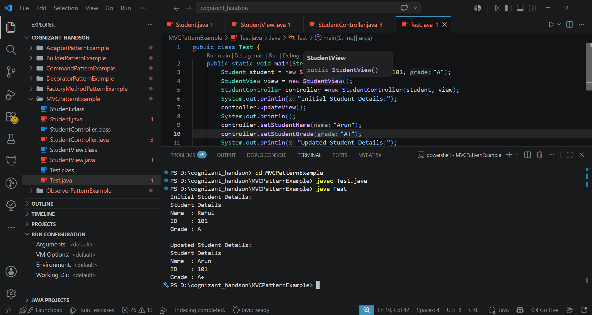
Exercise 11: Implementing Dependency Injection
